Topic of Discussion
“Population Pressure:
Land and Water”
Q&A Session
Presented by the Plan B Project Team

Plan B 4.0: Mobilizing to Save Civilization
by Lester R. Brown

Q: How do the dust storms from Africa affect hurricane season in Americas?

A: Scientists have many different theories concerning this topic:
“Wind over Africa blows west -- towards the United States -- carrying massive amounts of dust from sandstorms in the Sahara desert. As the dust passes over the Atlantic, it blocks out the sunlight cooling ocean temperatures below the ideal temperature to form hurricanes. "One dust storm at the right place at the right time might really help to interrupt the intensification, or even the genesis, of a potential hurricane," Evan said.
But before dust storms become a major player in hurricane prediction models, scientists will need to get a better understanding of how dust interacts with individual storms -- and what triggers the dust storms in the first place.”
(http://www.aip.org/dbis/AGU/stories/17097_full.html)

“As dust storms peak early in the hurricane season, researchers might one day incorporate dust data into forecasts to better predict sea surface temperatures and possibly the formation of hurricanes. Still, dust in 2006 accounted for less than half of the sea surface temperature change, leaving open significant influences from other factors such as El Niño, surface evaporation and wind.
"We're not saying that El Niño does not have a substantial influence on sea surface temperatures, but rather that dust is an important factor that we cannot ignore anymore. The 2007 hurricane season appears to be another one in which forecasts for an above normal hurricane season have failed," Lau says.”
http://www.nasa.gov/topics/earth/features/cooling_dust.html

Q: How many people have been displaced because of the expanding Sahara Desert?

A: While the environment plays a large role, there are many aspects and factors causing people to be displaced from Sub-Saharan Africa.
“Environment
Africa faces serious environmental challenges, including erosion, desertification, deforestation, and most importantly drought and water shortages, which have increased poverty and hunger by reducing agricultural production and people's incomes. Many of these challenges have been caused by humans; the environment can be said to be overexploited. Deforestation, for example, has been caused by humans seeking new places to live, farm, or obtain firewood. Drought, water shortage and desertification in Africa have been caused to some extent by global warming, which has mostly been caused by the effects of human energy use outside of Africa.”
http://www.worldhunger.org/articles/Learn/africa_hunger_facts.htm

Q: How many liters of water are needed to produce milk?


A:



3861 liters of Water = 1 Gallon of Milk

www.waterfootprint.org

Q: How many liters of water are needed to cultivate vegetables or fruits?

A: Some common fruits and vegetables:

1 Kilogram of Apples = 822 Liters of Water
1 Kilogram of Oranges = 560 Liters of Water
1 Kilogram of Bananas: 790 Liters of Water
1 Kilogram of Lettuce: 230 Liters of Water
1 Kilogram of Corn = 1222 Liters of Water
1 Kilogram of Tomato = 214 Liters of Water

www.waterfootprint.org

Q: What is the breakdown of water usage in the production of beef?

A: 1 Kilogram of Beef = 15415 Liters of Water

www.waterfootprint.org

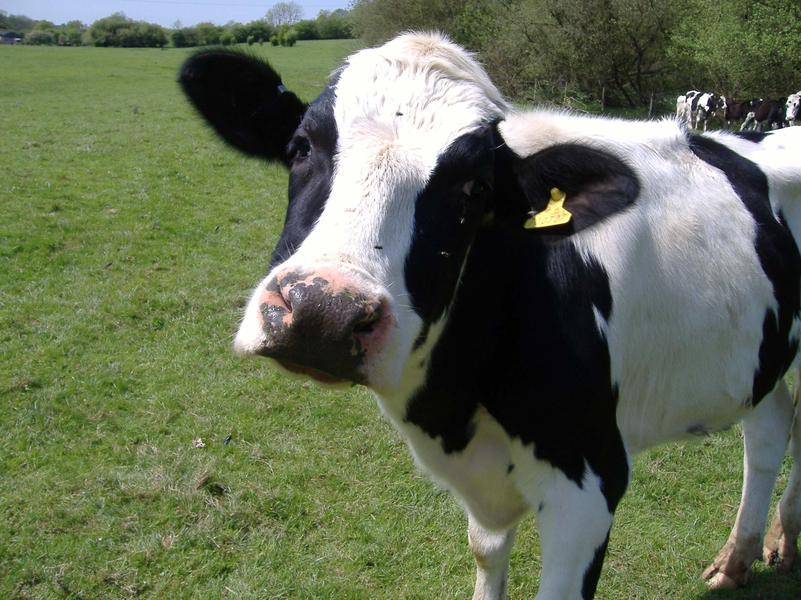

Q: Loess Pleateau…
A: Here are links to more information about the Loess Plateau:

Quality of Life Issues:
https://www.youtube.com/watch?v=HjNDiBCb-mE

